**Master Functional Document**

|  |  |
| --- | --- |
| **Application** | NGERP - Centra |
| **Service Bundle** | Master Management |
| **Service Request** | Vendor |

**Description :**

Vendor master is used to show list of partner’s who are vendors.

**Workflow Process :**

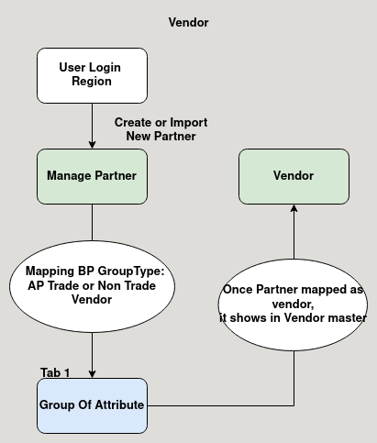

**Business Rules :**

* when partner is created in manage partner with the Business partner group type of AP Trade or Non Trade Vendor it shows in the vendor master.
* This master is not editable in both HQ and Region.
* When login HQ it shows list of vendors in all region.
* When login as Region it shows the vendor list for that region only.